Guruji’s Numeroscope

A numeroscope is a birth date expressed in a mandala. According to the numerology the whole cosmos is made up out of numbers with accompanying colors and vibrations.

All numbers together gives one number: the so called life path number. This number radiates all the other numbers of the numeroscope. For Guruji this is the number 9.

14-12-1918 = 9

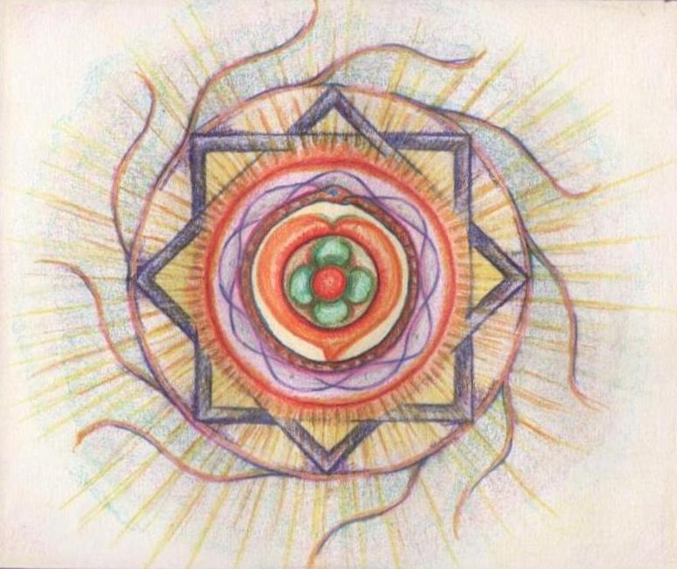

The number 1: individuality, leadership, enthusiasm, passion and is impulsive, direct. The element of fire. The color is red, its symbol is the sun.

The number 4 stands for stability, loyalty, discipline and is practical. Its color is green.

The number 2 is the moon and female energy and stands for duality, emotions and intuition. The color is orange. The element is water.

The number 9 is Guruji’s life path number. The element is fire. It is 3 times 3 (the number of the child, star). It is the number of the traveler( inwards and outwards), the artist, the idealist. The color is pearl-shell.

Number 8 is the number of authority, laws and rules, discipline. Its quality is firmness and the color is purple.

I made this mandala in 2012 for Guruji’s birthday.

Guruji’s intensity, generosity, playfulness, peacefulness, the structure of the Yoga (8), the spreading all over the world (9), the same spreading and penetrating but then to the inside, a growing consciousness, it all came to a form and color. In the centre is the heart (2), the symbol of love. Then there is the balance and peacefulness of the 4 and finally the 1, coming back four times, showing the pioneer and initiator, the passion and fire.

Special and colorful, vigorous , brilliant and radiant. That was Guruji. And that’s how I will remember him in thankfulness.

Maria Floris

The Netherlands